
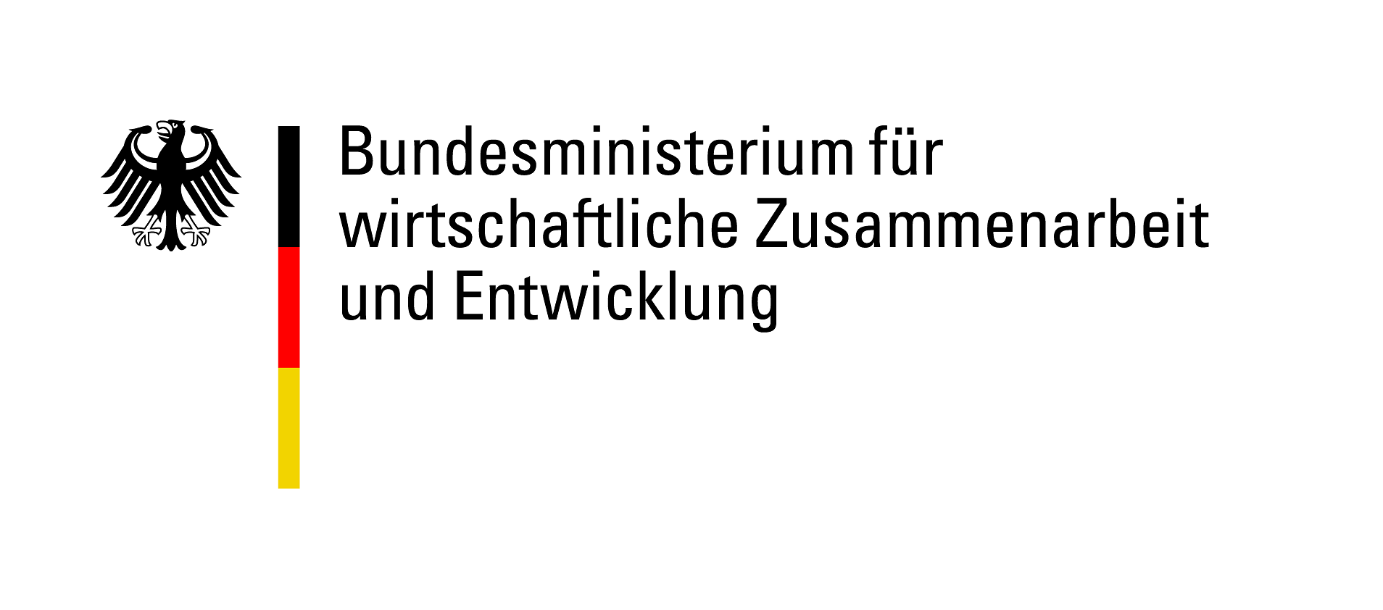


Engagement Global gGmbH
African-German Youth Office (AGYO)
Friedrich-Ebert-Allee 40
53113 Bonn
Germany

Application for a pilot project
Application to Engagement Global gGmbH
for a grant funded by the Federal Ministry for Economic Cooperation and Development (BMZ)
under the Teams up! Youth Exchange for Sustainable Development programme

1. Details of partnership
Organisation | German implementing organisation | Project partner in partner country
1. Post-assessment application authorisation received on |  | Not necessary
2. Name of organisation
3. Address
4. Tel. | + | +
5. Email
6. Website | www. | www.
7. Account holder |  | Not necessary
8. Bank |  | Not necessary
9. IBAN |  | Not necessary
Contact person(s) for project
7. Title, surname | , | ,
8. First name(s)
9. Tel. | + | +
10. Email
11. Fax | + | +

2. Start of partnership and joint activities so far
1. Since when have the project partners been in contact?  (Please enclose the official declaration of partnership here if there is one) | ☐ Contact established specifically for this project  ☐ Since: Click here to enter a date
2. How did the project partnership come about? What joint activities (max. 3) have been implemented? | 1. Title, from Klicken Sie hier, um ein Datum einzugeben. to Klicken Sie hier, um ein Datum einzugeben., country , number of participants , brief description  2. Title, from Klicken Sie hier, um ein Datum einzugeben. to Klicken Sie hier, um ein Datum einzugeben., country , number of participants , brief description  3. Title, from Klicken Sie hier, um ein Datum einzugeben. to Klicken Sie hier, um ein Datum einzugeben., country , number of participants , brief description

3. Basic information on the pilot project
1. Title of pilot project
2. Total duration | From Klicken Sie hier, um ein Datum einzugeben. to Klicken Sie hier, um ein Datum einzugeben.
3. Type, duration and location of joint activities (e.g. preparation, follow-up, main activity) | Type, , from to , location  Type, , from to , location  Please add any additional dates as appropriate
4. Which Sustainable Development Goal is the pilot project based on? | Please choose an option.
5. Brief description of the planned pilot project (max. 500 characters)
6. Please give a brief description of the project’s thematic focus (its link to the SDG, innovation and transferability to other projects) and, if possible, the chosen topic.

4. Details of project team members and participants
1. Project team members: Please list all persons involved in implementing the project (group leaders, speakers, project staff, etc.)
Name/job title | Number | Organisation(s) | Country (Germany or partner country) |  | Qualification | Role/task
Total
2. Project participants: Please describe the target groups participating in the project (adolescents, knowledge multipliers in paid or voluntary positions, etc.)
Target group |  | Number |  | Country (Germany or partner country)
Total
3. What are the project’s indirect target groups?
4. What will be the make-up of the group? What criteria will be used to choose team members and participants?
5. How will participant diversity be taken into account when deciding the make-up of the groups? (E.g. language, religion, impairments, gender, sexuality, education)?
6. What specific needs does the make-up of the group involve and how will they be catered for?
7. What measures to you intend to take to ensure successful (digital) communication between all project participants and team members in all phases of the project?

5. Objectives and achievement of objectives for the pilot project as a whole
1. Please list the objectives the project will pursue in line with the thematic focus stated in 3.6.
Objective 1
Indicators |  | Instruments
Objective 2
Indicators |  | Instruments
Objective 3
Indicators |  | Instruments
2. Please describe how the project aims to have a positive impact on international/development-related youth work.
3. What specific changes does the project aim to achieve for the target group? (E.g. new knowledge, skills, possibilities for action)?

a) Project team members
b) Project participants
c) Other target groups

6. Innovation and transferability of the project
1. Please explain what makes the pilot project innovative. What new added value (e.g. new approach) does it provide for international development-related youth work?
2. Please describe the transferability of the project’s content, objectives and methods
a. How do you intend to ensure transferability?

b. How can the project design, content, methods and/or objectives be transferred to other target groups?
c. What other organisations, project partners or groups in society can use the design or the content of the pilot project?
d. What other situations and contexts can the pilot project be transferred to?

7. Project phase schedule
1. Please give a brief outline of the schedule for the project.

It should date which activity (preparation, visits, interim phases and follow-up) is planned for which period (start and end dates) and in which country. Give a brief description of the content of each phase and the objectives, taking into account the principles upon which funding is based (partnership, participation, balance, evaluation, diversity and sustainability).

Please attach a schedule for each of the project phases. The “Programme schedule” template should be used for this. It can be downloaded from our website. Please describe your overall approach in terms of content in the schedules.
Period | Place/country | Activity | Content (summary) | Objectives | Attachment name
2. Use this space to add extra information about your overall approach

8. Sustainability, documentation and long-term impact
1. How will you evaluate/document whether the objectives have been achieved?
2. How will you ensure that project progress and the overall project are evaluated? What methods do you plan to apply?
3. How will you ensure the project is implemented in a sustainable way?
4. How will the implementation of the project and the results of each phase be documented?
5. How will the project results be disseminated in the long term and beyond the end of the project?

6. How will the participants be given motivation and connected with one another so that they can continue their civic engagement after the project ends?

9. Checklist
Please make sure the application and its annexes include all the required information and check them off below:
☐ Schedules for each project phase
☐ Preparation phase in Germany and partner country
☐ Main activity/visit
☐ Follow-up phase in Germany and partner country
☐ Other phases:
Please use the latest version of the “Programme schedule” template on our website to draw up schedules.
☐ Binding financing plan
Please use the latest version of the “Financing plan” template on our website to draw up your plan. Send the document to us as a PDF (not scanned) by email and post.
☐ Security and crisis plan
☐ Additional partners
Please submit this annex document if you are planning to work with additional partners. Please use the latest version of the “Additional partners” template on our website to draw up this document.

10. General information and declarations

- This application may be forwarded to the BMZ and the BMZ may disclose in confidence to the German Bundestag’s Budget Committee the name of the applicant organisation and the amount and purpose of the grant in individual cases where the Budget Committee requests this information.
- You undertake to give the BMZ or persons authorised to conduct audits unrestricted access to documents for the purpose of assessment and review and to allow them to visit projects. You must make available to Engagement Global gGmbH any images, project reports, accounts, documentation, etc. produced in connection with the project.
- We have taken note of Engagement Global gGmbH’s “Information on data processing” (Information on data processing - Engagement Global (engagement-global.de)
- We consent to Engagement Global gGmbH, Friedrich-Ebert-Allee 40, 53113 Bonn, Germany, in its capacity as the controller as per the European General Data Protection Regulation (GDPR) and the Federal Data Protection Act (BDSG), processing and disseminating the material we provide (images, project reports, documentation, etc.) for the purposes of PR work for the AGYO.
We consent to Engagement Global gGmbH using materials produced in relation to ourselves and materials we provide ourselves for the AGYO’s PR activities, for example, in its publications, on its website and in its social media channels. We are aware that this may also involve the material being forwarded to third parties, the Federal Ministry for Economic Cooperation and Development and the partner organisations/service providers to the extent required by the stated purpose.
We can revoke this declaration of consent with future effect at any time and without having to cite reasons by sending an email to datenschutz@engagement-global.de. This does not affect the legality of the processing that takes place prior to revocation. If we revoke our consent, our materials may no longer be forwarded or processed.
☐ We consent ☐ We do not consent

- We consent to Engagement Global gGmbH, Friedrich-Ebert-Allee 40, 53113 Bonn, Germany, in its capacity as the controller as per the European General Data Protection Regulation (GDPR) and the Federal Data Protection Act (BDSG) processing and disseminating the details of our organisation (name and country) and of the project (selected SDG, project duration, project description in Section 3.5) on the Engagement Global gGmbH and AGYO websites.
We consent to Engagement Global gGmbH using materials produced in relation to ourselves and data we provide ourselves for the AGYO’s PR activities, for example, in its publications, on its website and in its social media channels. We are aware that this may also involve the material being forwarded to third parties, the Federal Ministry for Economic Cooperation and Development and the partner organisations/service providers to the extent required by the stated purpose.

We can revoke this declaration of consent with future effect at any time and without having to cite reasons by sending an email to datenschutz@engagement-global.de. This does not affect the legality of the processing that takes place prior to revocation. If we revoke our consent, our materials may no longer be forwarded or processed.

☐ We consent ☐ We do not consent

- We hereby confirm that the planned project cannot be carried out without funding from Engagement Global gGmbH/BMZ.
- We hereby confirm that no other funding has been applied for or approved for the project for which this application is made.
- The project will not result in any subsequent expenses that cannot be covered by our own funds.
- Please place a cross next to the relevant statement below
☐ We are entitled to deduct input tax.
☐ We are entitled to deduct input tax to a limited degree.
☐ We are not entitled to deduct input tax.
- We confirm that the project for which the grant has been applied for has not yet started.

Place, date, signature of authorised signatory for the German implementing organisation or person authorised by law/statutes to act as a representative

